WWF Project/ Programme Plan (Proposal) Template
Version: October 2021
Purpose and Audience:
This template should be used to present clear and compelling information on the context and design for a mid-large (over €100K p.a.) project, programme or initiative. It should capture the planned work of the project team and partners (and thus guide implementation), support quality review and approval (see here), and as necessary enable resources and funding to be allocated or obtained from donors.
All submissions for funding to WWF donor offices should use this template, unless an alternative template is required by a primary donor (such as a PSP). Note that donors (both internal and external) typically assess plans according to criteria such as: relevance of the project, transformational potential, feasibility, sustainability, risk management, and sound M&E. Well-written responses to each section of the template will help a proposal to be seen as responding well to these criteria.

General Principles:
- Support a consistent approach. Use this template for all mid-large projects > €100K p.a. In general teams should develop an initial plan using the Concept template, and then a more detailed plan using this ‘Proposal’ template. (N.B. For smaller projects (< €100K p.a.), a Concept plus workplan and budget are sufficient for a project plan – this Proposal template is not required).
- …but adapt as necessary. The WWF Network Standards encourage a tailored approach according to the situation. In this spirit, project teams and reviewers should apply their own judgement when considering the level of analysis and detail needed in a project plan.
- Engage stakeholders (see guidance here). Project development should be participatory in nature and use forms of engagement appropriate to the context. It may be very important to include rights holders and potential partners, depending on the situation.
- Reference, and learn from other relevant work. In particular, where place-based work is planned, refer to the existing land/seascape plans to align strategies and to the associated safeguard mitigation framework/plans as appropriate. If project activities have already been screened and are covered by a mitigation framework/plan, ensure that these activities include the associated mitigation action. If the project includes new activities not covered by an existing screening and mitigation framework/plan, then those activities will need to be safeguarded (assessed, and if necessary, mitigated). Note any mitigation steps at appropriate stages in planning documents, including in section 4 of this template.

Other Guidance:
- Target length: Aim for 15-34 pages, including supporting figures and graphics, plus annexes.
(Before you finalise the document, be sure to delete the blue guidance text in this template).
- Further Guidance…is referenced through this document and is available on the Network Standards site and Project Guide. To provide feedback on this template please contact Will Beale wbeale@wwfint.org or Phyllis Rachler prachler@wwfint.org
- Seek input and support…from appropriate expertise such as Practice teams, quality management process management experts, communications specialists/ editors etc.
- Share the project with key audiences. This includes uploading project plans and reports to the Insight CPM database. Take care to avoid sharing any confidential information, such as data that is protected by regulation (such as personal data), or which is restricted by a confidentiality clause in a contract. See here for WWF-Int guidance on sharing confidential information.
- Terminology. This template is designed to be consistent with WWF Network Standards. For definitions of key terms, see WWF Standard Terminology here.
- Software. If the team wishes to use project management software, Miradi is recommended (see here for download instructions).
Project Information at a glance

Name of Project | Aim to give a clear, concise expression of the project
Date, Version
Location: | Specify the region, country, ecoregion or landscape (use the landscape database to select all landscapes/ seascapes that have a strong and direct relationship with the work to be carried out).
Link to WWFs and other relevant Global/ National Priorities | Briefly describe the project’s most direct contributions to: WWFs global priorities (Global Goals, Outcomes and Targets of the Practices and/or other Initiatives), your office’s strategic direction, and any key external agendas
Author(s) | Name and email address, department and organisation  And other contributors as appropriate. (For people outside WWF, do not include any personal information such as email address).
Implementing Office(s)/ Partners | Name of each office/ entity and point of contact - name and email.  Where more than one WWF Office will implement the work, clarify their roles e.g. which office will take the lead role in planning, coordination and reporting.
Project Duration | Approx start and end date
Budget | Total anticipated expenditure: (over the project duration)  Secured budget: (state the amount secured so far and its sources)  Requested budget: (for a proposal to a donor, state the amount requested)
Environmental and social safeguards | Indicate the risk categorization of the landscape/s (if a categorization memo is available). Mention if the activities in this project are covered in a landscape mitigation framework and/or plan.

Executive Summary (1-2 pages)
Hint: Always write this section at the end of the project development process rather than the beginning

The Executive Summary should support internal and external communications. Remember that the main audiences for this summary are likely to be decision makers, potential funders, fundraisers and communicators; if they were to read only this section, they should understand the essence of the project and be convinced of its importance.

In general the executive summary should:
- Introduce the project - include a high-level description of what the project will aim to achieve and how it will do so (the theory of change).
- Describe the main points from each section of the document that your audience should know.
- End with a conclusion - Outline the 3-5 main messages that you want the audience to note.

Table of Contents
Executive Summary (1-2 pages) 1
Table of Contents 2
List of Abbreviations 2
1. RELEVANCE 3
2. SCOPE, CONTEXT AND STAKEHOLDERS 3
3. GOALS/ OBJECTIVES, STRATEGIES & THEORY OF CHANGE 4
4. ENVIRONMENTAL AND SOCIAL SAFEGUARDS 5
5. RISKS AND SUSTAINABILITY 5
6. MONITORING, EVALUATION AND LEARNING 6
7. ROLES, CAPACITY AND GOVERNANCE 6
8. BUDGET AND FUNDRAISING 7
ANNEXES 7
Annex 1 Current Situation and Theory of Change (supporting sections 2 and 3) 8
Annex 2 Stakeholders/ rights holders (supporting section 2) 9
Annex 3 Environmental and Social Risk Mitigation Plan 11
Annex 4 Risk Management 11
Annex 5 Monitoring Plan 12
Annex 6 Workplan and Budget 14
Annex 7 Organisational/ Governance Structure (WWF and Partners) 15
References and Bibliography 15
Sign Off 15

List of Abbreviations
Please provide a list of any abbreviations or acronyms that are used in this document.

1. RELEVANCE
(1-2 pages)
Summarise the project’s relevance to key stakeholders and how it relates to other initiatives or to opportunities that may be leveraged. In particular:
- How is the project relevant to internal and external agendas i.e. WWF Global Priorities (Practice Outcomes, Targets and Initiatives), office strategies, SDGs, national and regional priorities?
- How is the project relevant to key stakeholders and, where appropriate, rights-holders, and how have these people been engaged in the design of the project? (This may require application of the Environmental and Social Safeguard Framework)
- How does the project relate to other efforts or previous work, and how does it add value? If the project is part of an overall programme that has already been approved, make this clear.
- Why should WWF and its partners carry out the project (rather than another organisation)?

2. SCOPE, CONTEXT AND STAKEHOLDERS
(2-8 pages)
This section should describe the project’s scope and context/ situation as well as the main stakeholders. It should support the case for WWF’s engagement. The writer should provide or reference relevant evidence (scientific evidence and/or insights gained through participatory or prioritisation processes) to support the statements made. Inclusion of a situation diagram (or similar visual) in Annex 1 is recommended to provide an overview of the situation and the relationship between factors. Key points to cover include:
- Scope (or boundary) of the project - geographic and/or thematic – and your justification for this choice. For example, consider the biological or environmental significance and/or social, political, land use and economic context. If relevant, provide a map and note key project sites.
- Focus – those elements which the project is intended to affect - and their current and desired status. For place-based projects, this typically relates to biodiversity and/ or human wellbeing (and is termed “targets” in the Conservation Standards).
- Context, including:
  - Pressures, Drivers and Opportunities - the main factors that directly or indirectly affect the project’s scope and focus. Where relevant, factors should be rated according to appropriate criteria so that the priority issues to be addressed are clear (see, for example, Direct Threat rating). Drivers that affect the situation may provide opportunities that can be exploited (e.g. institutional, social, political, economic, demographic factors). Include climate vulnerabilities where relevant.
  - Further key information on the socio-cultural, economic and political context. For example, cultural features, land tenure system, governance, tensions or conflicts.

- Actors/ stakeholders. Describe the main people and groups potentially affected by the project, those who otherwise have an interest in the project and those who could affect the project (note that these categories may overlap). For the different stakeholders, describe their power and influence, their needs and interests, their rights and main responsibilities (are they a rightsholder or a duty-bearer?) and their role in relation to the project.
Your analysis of the necessary levels of engagement may be shown in the form of a grid (see Annex 2), and could identify people such as: 1) disruptors to be influenced, 2) general interest groups to be informed, 3) those in power to be consulted, 4) those deeply engaged who you want to participate/ collaborate, 5) people with statutory rights whose consent is necessary for activities to go ahead, 6) future ownership to be empowered etc.

3. GOALS/ OBJECTIVES, STRATEGIES & THEORY OF CHANGE
(2-8 pages. Goals and objectives also to be shown in the monitoring table Annex 5)
This section should describe what the project will aim to achieve and how, and should be related to the main points noted in the scope and context above. Please summarise the goals/ objectives, the main strategies and why you have selected them, the theory of change and any key assumptions. Details should be provided in Annexes 1 and 2. Key elements to include are:

- Goals and Objectives which should be SMART (specific, measurable, achievable, results-oriented and time limited). As examples, these may relate to changes in biodiversity, outcomes for rights holders/ communities, behaviour changes of key audiences, reduction in pressures etc.
- Strategies (and/ or Activities and Outputs if appropriate). The strategies and activities selected should be the most equitable, effective and efficient possible, while respecting the rights of affected rights-holders. Highlight whether your strategy/ strategies are designed to address a single critical issue or several related factors.
- Theory of Change and the evidence base associated with it. The theory of change should briefly describe the logic of how your strategies will deliver short-medium term objectives that will ultimately lead to the achievement of goals. Results chains (or a similar visual) are recommended as a supporting tool. Highlight any key assumptions that need to be met for the project to succeed; this may include comments on the technical and economic feasibility of the project
- Partners and Rights Holders. Describe the ownership of relevant rights holders to the above strategies and theory of change. List the partners that are key to successful implementation and summarise their track record/ capacity; clarify which partners are already engaged and which you still need to get on board. Details of the stakeholder engagement plan may be shown in Annex 2 (mandatory for place-based projects).

4. ENVIRONMENTAL AND SOCIAL SAFEGUARDS
(1–4 pages). Primarily for place-based projects, but the tools can also be used to identify and mitigate risks for thematic projects that do not fall directly within a landscape.
This section should a) provide information on the safeguards approaches you are following, and b) give an overview of the status of the ESSF roll-out in the landscape and the mitigation framework relevant to the project. The guidance here outlines various ESSF-related scenarios (A to D), and outlines the expectations and steps to be followed in each case.
- To identify ESSF risks and develop mitigation measures, use the ESSF pre-screening tool and project-level screening tool as appropriate, and attach the completed mitigation plan template as Annex 4.
- Indicate if there is a Grievance Mechanism at the landscape or country level that can be used for any claims related to the project. Describe how this mechanism will be made accessible to people affected by the project, including to those potentially more vulnerable or difficult to reach.

5. RISKS AND SUSTAINABILITY
(1-4 pages)
This section should a) highlight any key risks and mitigation, and b) explain how the project’s desired impacts can be extended and sustained. This may inform your strategic approach and theory of change, as well as your workplans. Note that actions defined to help manage risks and safeguards may support the sustainability of project results; meanwhile designing without sustainability in mind presents risks to achievements. Key elements to cover include:
- Risks. Identify the main risks (e.g. social, political, economic, institutional, financial or capacity risks) that may affect the achievement of project objectives and state how do you plan to mitigate them; give details in Annex 4 and summarise the top 5 key risks using the table below. For guidance, see here. In addition, you may highlight circumstances where uncertainty could lead to opportunities.

Risk description (risk event, causes and effect) | Risk Rating (High, Medium, Low) | Mitigation actions | Residual Risk Rating (High, Medium, Low)

- Longer-term thinking, Sustainability and Exit Strategy. Outline how WWF might ultimately exit or transition from the project, and key considerations/ conditions for sustainability. Where relevant, share ideas on potential mainstreaming and scaling up of the project’s strategic approach. Mention any future phases that might be needed beyond the initial/ current phase.

6. MONITORING, EVALUATION AND LEARNING
(1-3 pages)
This section should describe how you will measure and analyse the project’s success, and take appropriate adaptive action. Focus on gathering and using information that will guide the project. More guidance here. Key points to cover include:
- Monitoring Plan. Develop a formal monitoring plan using the guidance in Annex 5. What you monitor should be based on priority information needs and what questions you need to answer through monitoring. Where appropriate you should link indicators to WWF’s Global Goals/ Outcomes and/ or to external international/ national agendas (as per section 1).
- Risks, mitigation measures, sustainability planning and safeguarding approaches should be built into your monitoring plan.
- Financial resources to support monitoring and evaluation should be incorporated in the budget (see Evaluations guidance here).
- Learning. Describe your learning approach e.g. how you will use regular reviews of progress against the monitoring plan to learn what is going well and less well, whether your theory of change if working, and how you will adapt. Clarify responsibilities and who will be involved in the process (potentially including partners and key stakeholders).

7. ROLES, CAPACITY AND GOVERNANCE
(1-3 pages)
This section should summarise how operations will be mobilised and managed to support successful implementation. Where relevant, please highlight any gaps or issues and explain how you will aim to resolve them. Detailed plans and arrangements should be provided in Annexes 5 and 6. Key points to cover include:
- Responsibilities, Capacity and Workplan. Summarise high level roles and responsibilities related to the major strategies and key activities. Assess whether the available skills and expertise meet needs, and highlight any key capacity gaps (WWF or partners). Provide a Workplan in Annex 6 (usually in detail for year one, and at high level thereafter).
- Governance and Partner Management. Using an organogram/ visual and supportive narrative, describe the implementation/ governance structure and decision-making responsibilities; this may involve partners and/ or different geographical levels. As relevant, confirm any due diligence conducted or required including capacity for risk mitigation, and how partner management arrangements will be formalised (grants, MOUs etc.).

8. BUDGET AND FUNDRAISING
(1-3 pages)
This section should summarise projected financial needs for the project, funding already secured, and the strategy for raising any additional funds needed. Where relevant, highlight any gaps or issues and explain how you will aim to resolve them. Key points to cover include:
- Financial Resources. Summarise projected funding needs and income already secured. As applicable include co-funding requirements. Where the project is ready to proceed with implementation, provide a detailed Project Budget in Annex 6 (use the WWF Budgeting and Cost Recovery Standards - unless a primary donor requires another format).
- Fundraising (Resource Mobilisation). Where relevant, outline the resource mobilisation strategy, including potential/ likely sources, for any additional funds needed.

ANNEXES
Annexes 1-7 below are mandatory. Use your judgement regarding the extent of supporting information that is useful to provide – for the benefit of the team, partners and key audiences. Where relevant you may provide further annexes beyond these.

Annex 1 Current Situation and Theory of Change (supporting sections 2 and 3)
Show here the Theory of Change and its relationship to the current situation by providing:
- An updated Situation Diagram, systems map or similar visual overview of the current situation.
- For place-based projects, also include a geographical map(s).
- Results Chain (or similar) Diagram(s) that links strategies to the objectives and goals

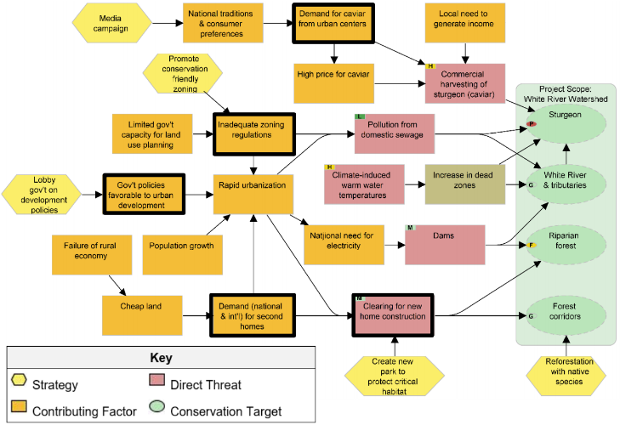
Example Situation Diagram, with key intervention points (in bold) and strategies (yellow) identified

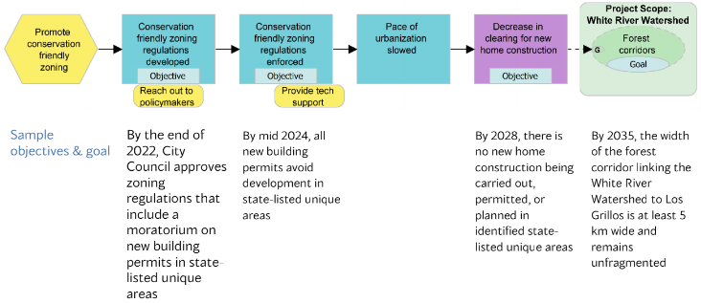
Example Results Chain (and associated objectives and goals), related to the above situation

Annex 2 Stakeholders/ rights holders (supporting section 2)
Summarise the information that you have gathered on stakeholders during project development and your preliminary plan for engaging with them through the project (or provide a link to your stakeholder engagement plan if you have this as a separate document). Detailed guidance and resources are available here.

BASIC GUIDANCE
- This annex is mandatory for place-based projects.
- An initial stakeholder analysis (example below, guidance here ) may help in developing the engagement plan. Note that within each broader stakeholder group, such as local communities, there are likely to be people who may be more vulnerable or marginalised than others.
- Your stakeholder engagement plan may start as a simple table (example below), summarising how different stakeholders have and will play a part in the project. Do not include personal information. Do include WWF and its role in the project!
- Your initial grouping of stakeholders will likely evolve as you develop an understanding of the different members of each grouping.
- A fully documented stakeholder engagement plan may include the studies as in the slide “Planning for Stakeholder Engagement” below.

Example - Stakeholder Analysis
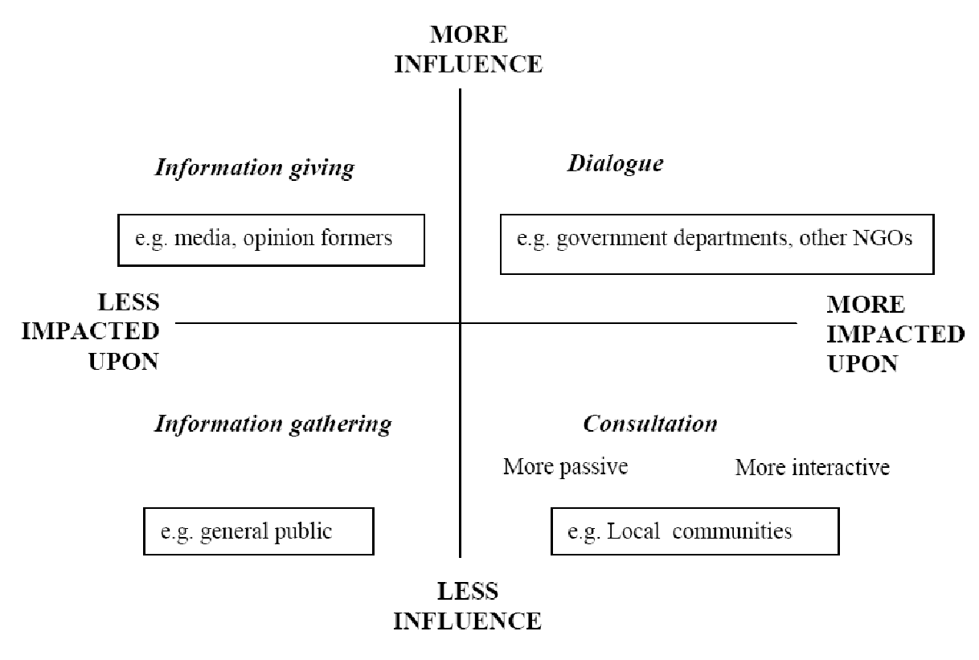

Example format - Stakeholder Engagement

Stakeholder | Stake | Attitude | Marginalised | Importance | Role in Project | Type & method of engagement
Dependent on resources  The nature of their stake in the resource (e.g. livelihoods, profit, lifestyles, cultural values, etc.), and the basis of that stake (e.g. customary rights, ownership, administrative or legal responsibilities,intellectual rights, social obligation, etc.) |  | If marginalized, note how e.g. gender, indigenous peoples, ethnic minorities, youth, disenfranchised groups |  |  | Identify potential roles in the project cycle (planning, implementation, M&E etc))
Types of right over resources
Knowledgeable about resources |  |  | Decide who are the key stakeholders - because of claims over or dependence on the resources, or their power, authority, or responsibility |  | Note, a particular effort may be needed to ensure the more marginalised people are engaged
Other resource interest groups eg CSOs & Gov, (partners) |  | Define if they are: positive  negative  neutral unknown  Use symbols like:  +++, - - -, O, ?
Other interest groups e.g. INGOs
Other groups of influence eg religious, educators, mothers, etc

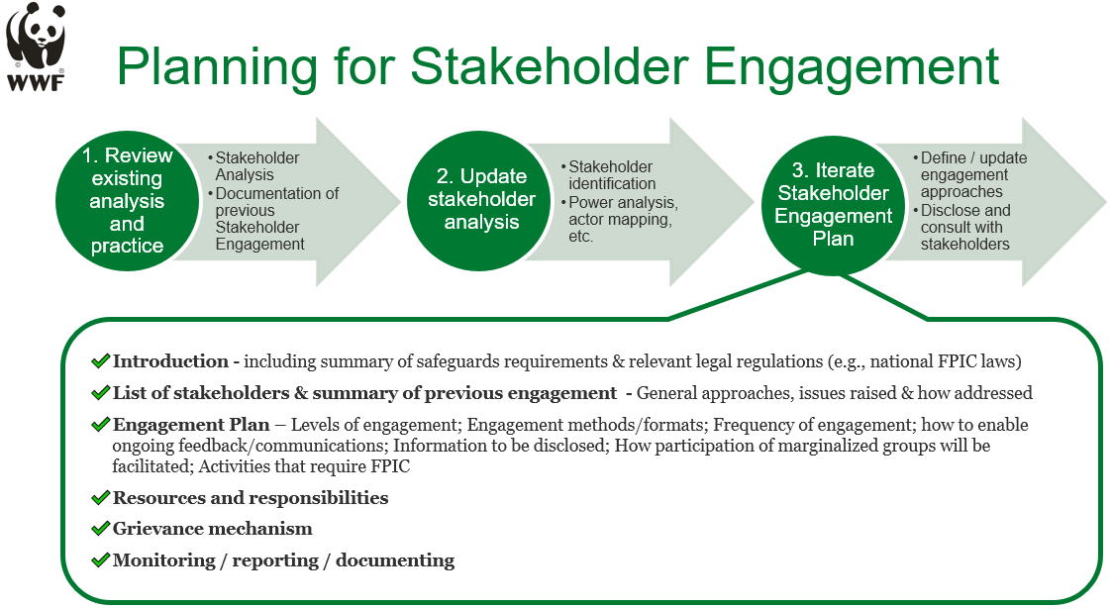

Annex 3 Environmental and Social Risk Mitigation Plan
(This annex is primarily for place-based projects, but the tools can also be used to identify and mitigate risks for thematic projects that do not fall directly within a landscape.
Please complete the mitigation plan template here for projects where material environmental and social risks have been identified and where no relevant mitigation framework exists at the landscape level.
- If a relevant mitigation framework at the landscape is available and approved, provide a copy.
- Use the project level pre-screening tool (link) and environmental and social risk assessment screening tool (link) prior to completion of the mitigation plan.
- The guidance here outlines all the key steps and related tools for integrating ESSF into the project process.
- For further guidance or to provide feedback, contact your ESSF focal point.
Project/programme ESSF mitigation plan template
Environmental and Social Risks | Mitigation measures | Implementation timeline | Assigned responsible (owner) | Implementation indicator/ means of verification | Budget/Resource Allocation
Summarise the main material environmental and/or social risks identified through the screening process.  Try to rank them in terms of priority/most urgent to address. | Detail the measures that are or will be taken by the project/ programme to avoid or mitigate the main risks identified.  Take into account that, in some cases, more than one mitigation measure may be needed to address those risks. | Indicate the timeline / duration to implement the mitigation measure. | Provide the name of the person responsible for the implementation of the mitigation measure.  If relevant, please provide the name of other parties (non-WWF) responsible for implementing the mitigation measure. | State which indicator /means of verification/ documentation will be used to measure the implementation of the mitigation measure.  (Subsequently provide information about implementation of the mitigation measures in the project’s technical progress reports - TPRs). | Indicate if the mitigation measures have been adequately budgeted/ resourced as part of this project or as part of another project.  Consider the budget needed to ensure adequate staff availability to complete the mitigation measures.

Annex 4 Risk Management
Prepare a detailed risk assessment using the template here and the guidance here.
- Depending on the risk level, used either the “Basic Risk Register” tab or the “Risk Register” tab.
- Involve specialists, experts, and senior team members to identify and assess risks.
- Provide a link to your completed risk assessment template.
- Include risks that need to be monitored in your monitoring plan.
- Keep your risk register up to date during the project to reflect emerging risks.

For further guidance, contact your risk manager or office's risk champion/focal point.

Annex 5 Monitoring Plan
Develop a monitoring plan that focuses on the project’s core information needs - to support adaptive management and assessment of the project’s effectiveness. Use either the format generated by Miradi, or the format overleaf (an Excel version is here; this mirrors Part 2 of the WWF Technical Report format).
Guidance on monitoring plans (see here for detailed guidance)
- Goals, objectives and strategies should be clearly defined before you attempt to develop indicators.
- The number of indicators should be the “minimum but sufficient” required to show whether the Goals and Objectives are being achieved and to test key assumptions (the theory of change).
- It is assumed that you will also monitor your Activities (in a simple, light way against your workplan) and your Resources/Finances (via your finance system).
- Monitoring of risks, sustainability and ESSF safeguards is also important e.g. via status updates to your risk and ESSF mitigation plans, or by including incorporate this in your monitoring plan.
- Operationalize your monitoring plan and think ahead to data analysis. The required format asks for significant detail so that methods, responsibilities, budgets, use of data, and audience needs are considered up front. Plan time to regularly ‘pause and reflect’ on progress.
- In practice, the monitoring plan may not be complete at the proposal stage but will be finalised in the early stages of implementation. Where this is the case, the plan for completion of the monitoring plan must be stated and included in the work plan (including baseline data collection).
- Align with relevant internal or external indicators as appropriate, adding columns as necessary. For example, wider programme goals, Global Practice Outcomes and 2025 Targets, SDGs.
- Social/ poverty/ gender data / indigenous peoples (where relevant). Where possible and appropriate, data should be disaggregated by social group. Consider also methods that allow the voices of partners and community members to be heard and recorded.
Extract of an example monitoring plan for a Land Use Planning strategy

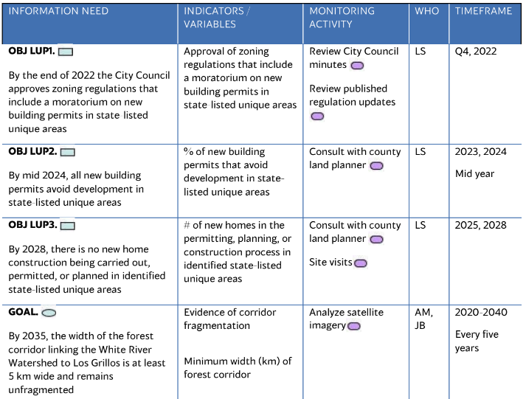
Format for the monitoring plan

Information needs | Indicators  (what will you measure?) | Related Indicators  (add column(s) to reference key internal or external indicators) | Method/ source of data  (how will you measure?) | Location  (where will monitoring be done?) | When  (timeframe & frequency of data collection) | Who to provide and use  (who will provide and analyse the data?) | Baseline data  (most recent figure and date, or when it will be defined) | Planned  intermediate result |  |  |  | Planned  final  result  (value and date) | Cost  (estimate for monitoring the indicator)
 |  |  |  |  |  |  |  | FY | FY | FY
Goals | Good goals are SMART and are normally linked to biodiversity or human wellbeing.
Objectives

Risks/ Sustainability/ other factors  Monitoring of both risks and ESSF Safeguards mitigation should be included either here or managed via status updated to your Risk and ESSF mitigation plans  (as necessary) |  |  |  |  |  |  |  | N/A | N/A | N/A | N/A
ESSF Safeguards |  |  |  |  |  |  |  | N/A | N/A | N/A | N/A

Annex 6 Workplan and Budget
Using the guidance below, provide a workplan and a budget.
- Normally the workplan and budget should be in detail for the first year, and at high level thereafter.
- For each year of a multi-year project, a revised (and detailed) workplan and budget is required for the upcoming year.
- There should be a clear correspondence between the main activities in the workplan and those in the budget.

Guidance on Workplans (detailed guidance is available here, Step 3.1). The workplan must include all activities, including those to support environmental and social safeguards

A Gantt chart format is preferred, using Miradi software or based on the format below (an Excel version is here). Other formats are equally acceptable provided they include the same parameters as below.

Strategy/ Activity - Description and Number. | Tasks/ Sub tasks | Who | When |  |  |  | Cost
 |  |  | Q1 | Q2 | Q3 | Q4
 |  | Individual/ organization primarily responsible. |  |  |  |  | Estimated cost and corresponding financial account code

Guidance on Budgets (detailed guidance is available here (Step 3.1) and the B3 template is here)
- Where a project is ready to proceed with implementation, provide a detailed project budget.
- The Project Manager is primarily responsible for developing the budget, with support from Finance colleagues.
- The Network Budget Standard, the B3 template, detailed budget template, budget checklist and Cost Recovery Standard are all available here. The standard B3 format must be used unless a primary donor requires an alternative format. The detailed budget template is recommended since it shows these activity-cost links, and it automatically rolls up the figures to the B3 format.
- Make sure the budget supports the recovery of core costs (see Cost Recovery above).
- Ensure that the timing of activities is realistic (e.g., factor in time for staff recruitments or completely new activities).
- Specify in-kind resources where relevant e.g., when matching funds are required.
- Any costs to support M&E and ESSF safeguards should be incorporated in the budget.
- Once the project and budget have been approved, use the budget as a management tool: monitor progress against the budget, analyse variances, and prepare forecasts.
- Communicate any foreseen changes to donors as early as possible.

Annex 7 Organisational/ Governance Structure (WWF and Partners)
Provide an organizational structure chart to present the organizational structure of the project, as well as any capacity assessments, due diligence assessments, agreements (MOUs, Programme Implementation Agreements), team descriptions, job descriptions of key roles, as appropriate.

Example: Visualization of activities of WWF and partners in a project area:

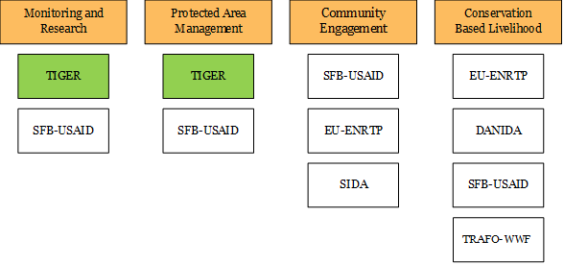

References and Bibliography

Sign Off
An example quality review and approval form is available here.

This template is available at www.panda.org/standards and https://sites.google.com/wwf.panda.org/networkstandards.
This template is designed to be applicable to all mid-large projects and programmes (over €100K p.a.). For simplicity, in this document the term “project” is used throughout to mean projects, programmes and initiatives.
Rights-holders, from a human rights perspective, are individuals or social groups that have particular entitlements in relation to duty-bearers. Duty-bearers are state or non-state actors that have the obligation to respect, protect, promote, and fulfil human rights of rights-holders. : this can include WWF. Being accountable to rights-holders involves giving them the opportunity to understand and influence the key decisions which are made throughout the project’s lifetime. Where Indigenous Peoples are involved, their Free, Prior and Informed Consent to all steps of the project development and implementation is essential. See the FPIC primer.
Environmental and Social Safeguards Framework
Context: the influences and events related to a particular situation, the set of things that are happening and the conditions that exist at a particular time and place. (The context is sometimes also known as ‘the system’)
Also known as Direct Threats
Also known as Indirect Threats, Root Causes, Enabling Conditions, or Contributing Factors
This could also include gender and any existing discrimination; arrangements and restrictions for resource access and use; any known tensions, conflicts or public concerns regarding development or conservation plans or projects.
Tools such as a stakeholder analysis or political economy analysis can help in understanding and prioritising this.
Goals and Objectives are also know as intended/ desired Impacts and Outcomes respectively. Goals may be long term and beyond the current phase of the project, or may be relate to a wider programme goal - yet they should be achievable in principle at least. Objectives should normally be achievable within the timeframe of the project e.g. 3-5 years.
Also known as Interventions
The level of detail included here and in Annexes 1 and 2 is a matter of judgement and will vary significantly between projects. It will often be appropriate to include only the broad strategies or major activities here in the main text and Annex 1, and provide a breakdown to smaller activities, tasks and subtasks in Annex 5.
A theory of change explains the underlying theory behind the project’s assumptions i.e. how the strategies will address the context in order to deliver the intended results. The CMP Conservation Standards suggest the use of Results Chains as a tool to help understand and describe your theory of change; it is helpful to also provide a supporting narrative.
For guidance on Sustainability and Exit Strategies see www.panda.org/standards Step 2.3

