University of Vicotira
DEPARTMENT OF BIOLOGY

INCREASES IN CHARCOAL PRODUCTION EFFICIENCY AND THE IMPLEMENTATION OF A SUSTAINABLE CHARCOAL SUPPLY CHAIN TO THE CITY OF TOLIARA IN SOUTHWESTERN MADAGASCAR

WORK TERM REPORT

In partial fulfillment of the requirements of the Biology Co-op Program
Winter 2010
Work Term 1

By

Julie Bremner

Performed at: WWF Madagascar
Ankilimalinke, Madagascar
Job Supervisor: Rina Andrianarivony
Job Title: WWF Explore International Youth Volunteer

ABSTRACT
The spiny forest ecoregion of Southwestern Madagascar is a zone of tremendous biodiversity and endemism. It is of key importance to the subsistence lives of villagers in the region and the urban population of Toliara that increasingly depends on forest fuelwood resources for their daily energy needs. Prolonged drought conditions in the area have led to increasing demands on the forest while villagers switch from farming to charcoal production as a means of earning a living. Urban population growth and resultant fuelwood demand increase has further exacerbated the deforestation of the spiny forest, which is currently exhibiting the highest rate of deforestation in Madagascar. WWF has stepped in to attempt to mitigate future forest loss through the establishment of the Synergy Energy Environment in the South West (SEESO) project. SEESO has as its goal the establishment of a sustainable fuelwood supply chain to the city of Toliara originating from the Atsimo-Andrefana region. The project is encouraging the adoption of a more efficient charcoal production technique, the plantation of trees for future charcoal production and the implementation of a system of regulations and governing bodies that will ensure the prolonged sustainability of the region’s forest resources. This paper analyses these systems through village experience and an analysis of the relevant literature. It discusses the wide spread adoption of the new technique partnered with effective enforcement of the Arrêté régional, including the establishment of plantations for use in charcoal production. These parameters create the potential to prevent future forest loss in the Atsimo-Andrefana region.

TABLE OF CONTENTS

LIST OF TABLES

LIST OF FIGURES

INTRODUCTION
Madagascar is an island of incredible biodiversity and is home to several thousand endemic species. The Spiny Forest Ecoregion in the southwest is particularly rich in endemic plants, up to 90%, and is dominated by the endemic family Didiereaceae (four genera and twelve species) and several species of Euphorbia (Fenn 2003, Gautier and Goodman 2003). This region is also home to a large variety of both locally and nationally endemic animals such as chameleons (Furcifer belalandaensis and F. antimena), radiated tortoises (Geochelone radiata), several species of lemurs (Lepilemur leucopus, Propithecus verreauxi, Lemur catt, and Microcebus murinus), tenerecs (Geogale aurita and Echinops telfairi), and many bird species (Coua verreauxi, Coua cursor, Xenopirostris xenopirosstris, Calicalicus rufocarpalis, Newtonia archboldi, Monias benschi, Uratelornis chimarera, etc) (Burgess 2004). The Spiny Forest Ecoregion covers the southwest coast and extends from the Mangoky River estuary at the southern end of the island north just past the town of Morombe. To the east it follows the western limits of the Anosyennes Mountains (Gautier and Goodman 2003) (see appendix 1 for a map of the region). The zone incorporates thousands of villages and several larger towns, most significantly Toliara (population 113 689 in 2005) (WWF 2006). The region is the driest in Madagascar. It is located in a rain shadow beyond the eastern mountains and is south of the prevailing northeastern rains. The region receives an annual average of 500mm of rain, in some localized zones it can be less than 350mm with the dry season lasting from nine to eleven months. In addition there are frequent cycles of drought that can last several years. The average annual temperature ranges between 33⁰C and 15⁰C (Burgess 2004). The topography is generally flat, increasing from sea level to about 200m elevation at the eastern boundary (Burgess 2004). The soil is composed in some zones of unconsolidated red sand and in others limestone (Burgess 2004). The plant and animal species inhabiting this region exhibit various adaptations to limited rainfall and drought conditions (Gautier and Goodman 2003), as well as poor soil conditions (Fenn 2003). These conditions and the forest type create a naturally slow rate of plant growth and regeneration (Burgess 2004).
The Spiny Forest Ecoregion is currently suffering from the highest rate of deforestation and landscape degradation in Madagascar (Ratsirarson and Silander 2003). The remaining spiny forest covers an estimated 14,115 km², only 3.2% of which falls within protected areas (Fenn 2003). A protected area in the Atsimo-Andrefana region of particular importance is PK-32 Ranobe. This forest protected in partnership between WWF and the inter-communal association (MITOIMAFI) is home to many endemic and endangered species including a possible new and rare species of giant-mouse lemur (Mirza spp.) recently discovered by researchers in the area (WWF March 25, 2010). These small pockets of protected forest are currently too small and too dispersed to maintain viable and healthy populations of the region’s unique species in the long term (Fenn 2003). In the case of Pk-32 mining concessions surround the protected area and the unprotected gallery forest is currently being exploited for charcoal production (WWF March 25, 2010). Nearly a third of the remaining spiny forest cover is deemed degraded (Gautier and Goodman 2003). The principal cause of this deforestation is the supplying of urban centers with charcoal and fuel wood (Fenn 2003). The charcoal needs of Toliara alone require an estimated 8000 ha of forest annually (Durbin et al. 2003). Charcoal and to a lesser extent fuel wood are the most affordable and accessible sources of household fuel needs, an estimated 300,000 m³ of wood is used annually, 93% in the form of charcoal and the remaining 7% in the form of fuel wood. Gas and electricity contribute a very minor amount of energy and if used are generally used in conjunction with charcoal and only by those who can afford the high and rising prices (WWF 2006). In 50 years the population of Toliara is expected to increase two and a half times to 259 366 inhabitants. There is no evidence to suggest that socio-economic conditions will have improved enough to eliminate dependency on charcoal in that time and thus the demand on the forest will rise significantly, charcoal consumption will increase by an estimated 27% (WWF 2006). Other causes of deforestation in the region include logging to supply urban areas with building materials and the clearing of land for cultivation or livestock grazing (predominantly cattle and goats). Invasive species such as prickly pear (Opuntia spp.) are another cause of forest and habitat degradation (Burgess 2004). Several plant species in this region are important to local village populations as sources of food, medicinal remedies, building materials and income (Ratsirarson and Silander 2003). Both the rural and urban populations in the Spiny Forest Ecoregion are dependent on the forest for many aspects of their lives. In a region suffering from extreme poverty it is apparent that forest conservation is important not only to preserve biodiversity but to maintain and improve the standard of living.
The World Wide Fund for Nature (WWF) in Madagascar has been working in the Spiny Forest Ecoregion since 1997. Their mandate in the area is “to protect, restore, and maintain the exceptional biodiversity...through a system of conservation areas efficiently managed in harmony with the livelihoods of the local populations” (Rasolonandrasana 2010). The Synergy Energy Environment in the South West (SEESO) project operated by WWF Madagascar is currently working in the Atsimo-Andrefana region of the spiny forest to establish a sustainable charcoal supply chain to the city of Toliara (Appendix 2 shows a map of this region and the current activity distribution). The project, begun Feb 1, 2008, will run for 36 months, working closely with the Forestry Department (DGF), the Regional Forestry and Tourism Department (DRFT), the Atsimo-Andrefana Region, the urban District of Toliara and the rural Districts of activity and receives funding from the European Union and WWF Switzerland (WWF 2010). The SEESO project recognizes that charcoal provides the most accessible fuel for household cooking needs both in villages and in the urban area of Toliara, it also provides a livelihood for many villagers who work in production, transportation and sales. This livelihood is increasingly important in light of recent drought and crop failures and in some areas diminishing fish populations. The SEESO project is therefore working to create a system of regulations that will help stabilize the industry and minimize future forest loss due to charcoal production (WWF 2010). The project works in four main areas: 1) Assisting with coordination and implementation of strategies to create a sustainable supply chain and assisting other key players in fulfilling their roles; 2) Strengthening and empowering local administrative bodies in order for them to better control and regulate the charcoal supply chain; 3) Planting trees for future use in charcoal production with concerned communities and private individuals; 4) Assisting village communities with the sustainable management of their charcoal producing forests (WWF 2010). In addition to regulating the charcoal trade and encouraging producers to operate within the system SEESO has laid out, work must also be done to create alternative sources of income. There are currently more charcoal producers than is necessary or sustainable. Drought and the resultant crop failures have driven many farmers to produce charcoal as it is currently their only alternative source of income if they remain in their rural villages. According to the testimonies of many local charcoal producers it is not a lucrative business, many would prefer to return to agriculture or fishing, they want help in finding ways to do so.
Between February 10 and May 8, 2010 the SEESO project received six international volunteers through the WWF International Youth Volunteer Programme: Explore. One group of four volunteers based in the community of Ankilimalinika, 52km north of Toliara, worked in three communities (each community is comprised of 8 to 15 villages) to help raise awareness of the SEESO project’s goals. Daily tasks for these volunteers included planting trees to establish forests for use in charcoal production and education regarding the importance of planting trees and protecting reforested areas. It also included meetings with local charcoal producers to explain the new permits required to transport charcoal, the new charcoal producers associations and the new improved technique of charcoal production. This new technique of charcoal production was of particular interest to the volunteers as it raises many interesting questions. Charcoal is produced by burning wood in a pit that is partially underground then pilled with wood and covered with earth. The new technique has endeavoured to improve the design of this pit to increase the yield. In application the new technique not only increases yield but it also decreases the likelihood that the wood will burn too quickly and turn to ash. The risk of forest fire is also decreased (WWF 2009). Producers have noted that although this new technique is somewhat more time consuming and involves more effort to prepare they prefer it because it producers a more dense, higher quality of charcoal. This raises the question of sustainability; will this technique ultimately cause producers to use less wood to yield the same amount of charcoal as they were previously producing? Or will the temptation exist to harvest more wood in hopes of producing more, better quality charcoal? By encouraging the adoption of a more efficient technique of charcoal production SEESO risks giving producers a tool to over produce for personal profit. Measures must be put in place to limit the number of producers and the amount they can transport. Planting trees to create a renewable source of charcoal wood is also of great importance to the success of the SEESO project. This has been acknowledged by WWF and the regional government of the Atsimo-Andrefana in their creation and signing of a legally binding plan of action that aims to create a sustainable charcoal industry while protecting the remaining natural forest (Raheliarisoa 2010). The wide spread adoption of the new technique partnered with effective enforcement of the Arrêté régional, including the establishment of plantations for use in charcoal production will prevent future forest loss in the Atsimo-Andrefana region.

DISCUSSION
Increasing efficiency in charcoal production and consumption
Charcoal is produced by first cutting trees and preparing a pit. The pit is then filled with wood and covered with earth. The pit is lit and the charcoal will smoulder underground for several days, then it is put out and the charcoal is cooled. The finished product is now ready to be bagged and sold.
The new technique of charcoal production alters the construction of this pit to include a chimney and more air holes for better ventilation. Other significant differences are that with the new technique there is a drying period for the wood before it is burned. The ventilation holes on the pit are placed at the opposite end of the stove from that of the prevailing wind (traditional technique places holes towards the prevailing winds). The logs are packed tighter in the pit as well. The results are typically more charcoal produced (eight 50kg bags vs. five 50kg bags with the traditional technique), a lower likelihood that the process will yield only ash and a decreased risk of forest fire (WWF 2009). Table 1 describes the key differences in the two techniques observed during a workshop put on by WWF with local charcoal producers. Preliminary evidence suggests that this new technique of charcoal production will overall yield more charcoal from the same amount of wood. In fact producers already using the new technique surveyed by Explore volunteers reported that they preferred this technique as it yields a better quality charcoal for which they can earn more money. WWF study data indicates that the yield can be improved to 15% of the original volume of wood, as opposed to the 10% yielded by the traditional technique (WWF 2006). The net result of this increase is significant when you consider the vast quantities of charcoal necessary to supply Toliara. In effect the population of Toliara is currently about 104 000 people, at a yield of 10% and 15% the amount of charcoal consumed annually per person equates to 2.5 m³ and 1.7 m³ of natural wood respectively (WWF 2006). If all charcoal production could achieve a yield of 15% in 50 years when the population of Toliara has increased to approximately 260 000 inhabitants this will results in a net savings of 208 000 m³ of natural wood in that year alone.
The international centre for agricultural research for development (CIRAD), a French NGO operating in Madagascar has implemented a similar strategy for an improved charcoal supply chain to the city of Mahajanga, operating in the Boeny region of southern Madagascar. Their project was very similar to that of SEESO and ran from 1999 to 2008 when control over the management of forest resources was handed over to local governing bodies. Mahajanga, a city of about 200 000 people, exhibits similar charcoal demands to Toliara (about 1.75 m³ per person per year) (2008, Montagne). Their population is growing at a significant rate as is their charcoal consumption which is derived entirely from natural forests. CIRAD has achieved yield results of up to 20% (an average of 16.7% yield) with the improved technique of charcoal production in this region (2008, Montagne). These impressive yields are achieved only by those charcoal producers who are registered in associations and practicing charcoal production as a professional, legal, trade; the numerous illegal and occasional producers have less technical training and typically achieve yields of around 10%. The impressive increase in yield by registered producers comes as a result of years of training and education within the CIRAD program in the Boeny region (2008, Montagne). Between 1988 and 1994 CIRAD experimented with several improved charcoal production techniques before deciding on one resemblant to what SEESO is employing today. They emphasize that in order for a new technique to be adopted and effective it must comply with three main principles. First it must resemble the traditional technique in that it derives its heat source from some of the wood used for charcoal. Second it must be financially feasible for villagers. All materials needed to construct a charcoal pit should be found in the natural environment, any equipment that would have to be purchased would be a limiting factor for most charcoal producers. And finally the new technique must conform to existing legislation regarding use of forest resources. This includes ensuring that only permitted species are being used to produce charcoal from permitted areas of the forest (2008, Montagne). Perhaps the most significant difference between the Atsimo-Andrefana region and the Boeny region is that the SEESO project is beginning in the Atsimo-Andrefana region at a time when it is exhibiting a deficit of forest materials to meet the demands of the city of Toliara. The Boeny region began managing its charcoal production at a time when urban demand had not yet outweighed rural supply, and in fact it still has not (2008, Montagne). SEESO faces the major challenge of having entered the scene at a time of ecological catastrophe.
The Atsimo-Andrefana region is already suffering from serious deforestation, the adoption of a charcoal technique with a higher yield will only slow the current rate of forest loss, and in light of the continually increasing demands of the city of Toliara it is clear that this new technique is only a starting point. In fact no change in the current trend of forest loss is likely to be seen until a massive reforestation effort has been undertaken and those trees have reached the point of being usable for charcoal production (2008, Montagne). Currently 3 of the largest cities in Madagascar, Antananarivo, Antsirabe and Fianarantsoa, derive the majority of their fuel wood from forest plantations (2008, Montagne). The challenge faced by SEESO is now one of geography. The major cities currently supplied by plantation are on the high plateau of the central interior of Madagascar. The climate is cooler and more humid than the spiny forest ecoregion. Explore volunteers planted with villagers in the community of Tsianisiha, about 60 km north of Toliara, they observed extreme rates of plant mortality. Frequently many plants die in the nurseries, depending on the location and the year all of the plants may die in the nursery (as observed in one nursery in the community of Ankilimalinika, where, in the previous year the nursery had had outstanding performance, this year there was no rain). Those that survive to planting are faced with dry soils and scorching sunlight. When volunteers returned to plantation sites one month after planting they found that almost all the plants had died from heat and lack of rain. In one exception, flood rains from a cyclone had drowned a small plantation. Volunteers also witnessed cattle and goats grazing on recently reforested lands. Yet there was always a strong desire to plant, and replant when necessary. In discussions with volunteers villagers expressed their understanding of the importance of planting to create a sustainable supply of fuel wood.
Over the next 50 years the charcoal demands of the city of Toliara will require up to 300,000 m³ of wood annually (WWF 2006). In order to achieve this, the plantation of trees to be used for charcoal production must become a priority. A study produced by WWF in 2006 estimates that over the next 10 years 30 000 ha of forest will need to be planted. This plantation coupled with a sustainable exploitation of natural forests will provide a strong base of plantation forest for future use as well as promote natural forest regeneration by slowly switching from natural to plantation resources, (see appendix ), (WWF 2006). The 30 000 ha necessary for plantation will be chosen on the basis of soil composition, previous land use and local rainfall. Research conducted by WWF found large plots totalling 16 850 ha (WWF 2006). These plots are large enough that they will benefit from mechanical ploughing, such activities have already been undertaken by WWF in the zones surrounding the RN 7 (route national 7, the main highway east from Toliara), farmers have remarked that they are able to plant crops amongst the young plantation trees. This ploughing of fields by WWF obliges farmers to plant or they must repay the cost of ploughing. It also encourages farmers to plant by reducing the manual labour on their part as well as benefiting the young trees by removal of weeds and maintenance of the agricultural space. The remaining hectares needed to make up the 30 000 ha will come from small community plots, many along the RN 9 (the main highway north of Toliara). This is the zone where volunteers planted trees with villagers in community plots. The plantation efforts undertaken in these plots generally covered between 1 and 6 ha. These trees also suffered the most under drought and poor soil conditions. There was also a general lack of knowledge concerning proper planting technique (spacing between plants, removal of plastic sac from saplings, adequate depth of hole, etc.) observed by volunteers. However a strong desire to plant exists, it seems that more education is needed in this zone as well as a more rigorous selection of tree species that will survive the challenging conditions, especially given that these plots are not ploughed or irrigated.
As part of the study conducted by WWF and CIRAD into the feasibility of planting trees a rigorous examination of soil and climatic conditions was undertaken with the aim of determining the optimum species of trees for plantation. The study found that these trees must be adaptable to the low rainfall of the region (avg. 500 mm/year), exhibit rapid growth, yield 5 to 10 m3/ha/year of wood at the exploitable age of 7 to 10 years, be resistant to forest fires and have multiple uses beyond charcoal production (WWF, 2006). Such wood, according to WWF, would likely come from Eucalyptus (Eucalyptus camaldulensis). Several tree species could potentially provide enough wood, including Acacia albida, Acacia nilotica and Prospis juliflora, however none of these species quite match the exceptional performance of Eucalyptus camaldulensis under these environmental conditions. This species of tree meets or exceeds the criteria for rapid generation of plantations. Most notably it has a yield of 12 m3/ha/year at 10 years of age, more than what is required (WWF 2006). Lebot and Ranaivoson (1994) remarked that at the time of their study Eucalyptus spp. plantations covered over 300 000 ha in Madagascar and provided significant supplies of wood to major urban zones such as Antananarivo. E. robusta and E. grandis are the two principal species currently used in plantations in Madagascart primarily because these two species have proven to be best adapted to the plantation zones which are largely at higher elevation and exhibit increased precipitation as compared with the spiny forest ecoregion (Lebot and Ranaivoson 1994). E. camaldulensis the species chosen for plantation in the spiny forest region has been found to be poorly adapted to lower temperatures and thrives in the climate of the spiny forest (Lebot and Ranaivoson 1994). There is some concern regarding high water demands of Eucalyptus spp.. A study by Kallarackal and Somen (1997) of eucalyptus plantations in a zone of India with an annual rainfall of 1302 mm found that many Eucalyptus spp. exhibit increased water use efficiency and are therefore good candidates for plantation in zones where water conservation is also a priority. This is the case due to Eucalyptus spp. ability to close their stomata for several hours a day during periods of extremely dry conditions (such as the pre-monsoon season in the study region), furthermore it was observed that photosynthetic activity was not disrupted by this adaptation and thus it had no effect on the yield of the trees (Kallarackal and Somen 1997). A concern raised by Lebot and Ranaivoson (1994) regarding the plantation of Eucalyptus spp. in Madagascar is the limited genetic diversity of the exotic species. Since most trees in plantations are derived from a relatively small sampling of Australian trees imported over a century ago, a high rate of inbreeding has occurred. A result of this is the poorer yield of trees grown from seeds produced from Madagascar eucalyptus than those grown from newly imported Australian seeds. Lebot and Ranaivoson stress the importance of increasing the genetic diversity of Eucalyptus spp. in Madagascar. They go on to state that “Eucalypts are so important for fuelwood production in Madagascar that an efficient genetic improvement programme would produce considerable economic results” (Lebot and Ranaivoson 1994). Clearly the origin and diversity of seed used in plantations is something that should be considered by SEESO as they strive to increase production and yield of eucalyptus plantations.
A further strategy to increase efficiency mentioned in the SEESO project is the adoption of more efficient charcoal stoves in an urban setting. Several models of stoves with varying levels of increased efficiency have been inventoried and are available in the Toliara market (within a wide price range, 800 to 6000 Ariary) (WWF 2006). There is currently a rate of adoption of less than 1% which can be largely accounted for by price restrictions and lack of awareness and education on the subject (WWF 2006). SEESO hopes that 100% adoption of improved stoves will be possible over the next 20 years. If this is the case the projected wood savings over the next 50 years could be up to 150,000 m³(WWF 2006). However, Zein-Elabdin (1997), in his review of the literature found that as of 1997 no increased efficiency stove program had seen an adoption rate of the new stoves of more than 50%. Zein-Elabdin (1997) also examines economic rebound effects relating to increased purchasing power of the household due to savings as a result of increased charcoal use efficiency. He cautions that although improved stoves do cause a reduction in overall charcoal use (assuming their increase in efficiency is substantial enough) this reduction is less than the overall percentage of increased efficiency as a result of these economic factors (Zein-Elabdin 1997). In another study by Mead (2005), he points out that where improved stoves have been used they improve energy use efficiency by an average of 20% and as an added benefit reduce smoke output which in turn reduces smoke related respiratory illnesses, common under indoor woodfuel cooking scenarios. It is therefore advisable for SEESO to push for the widespread adoption of increased-efficiency-stoves, however it is likely that estimates of their overall savings are higher than feasible. SEESO projections for the next 50 years also include a 0.5% decrease in charcoal consumption per person per year, resulting in a wood savings of 160,000 m³ over the next 50 years (WWF 2006). SEESO expects that this savings will occur as a result of a slight increase in the amount of petroleum products used over the next 50 years. Although rising petroleum prices have in fact decreased the amount used within the city of Toliara by 60% between the period of 2000 and 2005 (WWF 2006). Furthermore, when petroleum products or electricity are used in a household they are as a supplement to woodfuels (WWF 2006). There is no clear indication that this supplementation will decrease the overall use of charcoal even if a greater amount of supplementation is economically possible. As discussed by Zein-Elabdin (1997) consumption is often a function of income, thus it is more likely that as income increases (a necessary parameter in the consumption of more petroleum or electricity due to their high costs) households will consume more energy total than they previously did. The estimate for wood consumption by the city of Toliara in 50 years time after the implementation of the SEESO project with 100% adoption of improved stoves and a 0.5% per person decrease in consumption is 345,000 m³ per year. This is likely unrealistic. Their projection in the absence of improved stoves and reduced consumption is 653,000 m³ per year, this too is likely too high. The more realistic estimate likely lies somewhere in the middle a re-evaluation of the future trends in this area would be beneficial in terms of creating more accurate consumption projections and in turn the necessary plantation requirements.

Implementation of sustainable management of the supply chain
With an increased capacity to produce and consume comes a risk of over production. Jevon’s paradox is an economic argument that states that “increased demand for a resource due to efficiency will occur because of a rising level of possible production” (Polimeni and Polimeni 2007 p. 64). A production technique with higher yield certainly constitutes “a rising level of possible production” and thus measures must be put in place to ensure that this does not increase individual demand as this will add pressure to the forest. As discussed in the previous section more efficient stoves introduced in Sudan actually caused an increase in charcoal consumption due to the money savings which generated additional purchasing power; overall the efficiency of the stoves still led to a net decrease in total charcoal consumption (Zein-Elabdin 1997). Thus in the case of charcoal production efficiency, regulatory measures must be put in place to ensure that the efficiency is not outweighed by potential demand.
Such regulatory measures have been clearly laid out in a regional decree that as of April 2010 has been signed and adopted by the regional government Atstimo-Andrefana (Raheliarisoa 2010). This section will discuss the feasibility of the major components of this decree. Section one of the decree discusses the organization of local charcoal producers into associations. From volunteer experience this has been largely successful in the communities of Ankilimalinika, Belalanda and Tsianisiha. From discussions with both association presidents and members it is clear that the majority of those practicing charcoal production as a full time occupation are registered and see a benefit to belonging to these organizing bodies and to the professionalization of their trade. An alarming fact that came out of these discussions is the number of non-registered producers. In the village of Ankatrakatraka the president of the association said that he had registered about 70 men, but he estimated that over 300 are currently producing in his village area. Similar numbers were offered by other charcoal association presidents. It is clear that the forest cannot support this number of producers, and in fact many of these unregistered producers are only occasional producers at times of financial need. Times are financial need are, however, becoming increasingly common as drought and in some areas fish stock depletion are driving villagers away from traditional sources of income and food. Villagers stress that they would like help returning to their preferred occupations with education concerning improved drought-resistant farming practices and better irrigation systems or improved fishing techniques. A canal project funded by the African Development Bank is currently underway. It will supply the communities of Tsianisiha and Ankilimalinka with an irrigation canal as well as the construction of several wells in the area. The hope is that this much improved access to water will provide more farming opportunities to local residents (ADF 2010). This will only solve a portion of the problem since a large portion of the charcoal producing region is not geographically close enough to the canal zone to benefit from it, thus more employment opportunities in these areas should be a focus. Given that this falls outside the scope and capabilities of the SEESO project WWF may wish to consider partnerships with other NGOs working in the development field to meet this goal.
Increased enforcement of forest resource use is also necessary to prevent unregistered producers from cutting trees. The regional decree calls for each fokotany (village) to elect a KASTI member (village forestry officer in charge of enforcement of regulations listed in this decree and other forestry laws within the region) (Raheliarisoa 2010). This has been successfully done. A major flaw however is that these KASTI members are unpaid and as a result are only capable of devoting a tiny proportion of their time to this job. The scope of the work laid out for KASTI members necessitates their being paid. It also necessitates that they are provided with proper identification. Volunteers were told of cases of imposters posing as KASTI members and extorting money from charcoal producers for various reasons. This undermines the power of KASTI members and weakens the villagers trust. A great deal of the power of the KASTI lies in the fact that they are elected at the village level and contribute to a ground up system of enforcement that SEESO has put in place. Several studies cite the importance of forest management at the village level, one, so that villagers may reap more direct (financial) benefits from their resources and two, so that there is more village ownership in the management of those resources (Chomitz and Griffiths 2001, Mead 2005).
Paying the KASTI members will fall into the more long term financial goals of the regional decree (Raheliarisoa 2010). Currently transport permits must be sought in order to bring charcoal into the city of Toliara. The adoption of this is not yet widespread. This permit process will eventually be expanded to include quotas and set retail locations. This will allow for the enforcement of a taxation system to be levied on charcoal production, transportation and sales. In turn the financial benefits of these taxes will be redistributed amongst the varying governing bodies including the KASTI, the village charcoal producers associations, the regional government, and forestry officers (Raheliarisoa 2010). In several instances a system of taxation has been found to benefit the sustainability of the charcoal supply chain. For instance in the case of the CIRAD project in the Boeny region, a system of taxes levied at various levels of the supply chain, similar to that proposed in the Toliara supply zone is contributing to the long term costs of running the system (Montagne 2008). Chomitz and Griffiths (2001) found that in the Sahel 2 levels of taxation present many benefits. First the village level tax provides funds to ensure the continued management of the resource and operation of village governing bodies (in the case of Atsimo Andrefana, the charcoal producers association, village and community government and KASTI would benefit divided 60% towards community level and 40% towards regional level) (Raheliarisoa 2010). They also point out that this village level tax serves to transfer income from urban consumers to rural producers. Chomitz and Griffiths (2001 p.290) propose a second “city-gate” tax. This ensures that even illegal producers are taxed, thus limiting incentive to circumvent the rules. The application in Atsimo-Andrefana is somewhat different since illegal producers (those who do not belong to registered associations and thus do not obtain permits) will have their charcoal seized by gendarme or KASTI along the road to Toliara. This also has the potential to serve as a deterrent to illegal production, however in application charcoal producers told volunteers that it is currently no problem to transport charcoal without a permit. The issue of gendarme corruption along the road is a problem faced by SEESO, currently charcoal transporters must pay to pass at gendarme stops with or without permits. This corruption is an ongoing problem and one outside the capabilities of SEESO and this paper to address. What is clear is that there must be alternative motivations to produce charcoal within the parameters of the system laid out in the regional decree. Enforcement by paid KASTI members, as discussed, is one solution. Another is the proposed retail locations. Once these sites are established and enforced as the only sales points within the city the importance of presenting permits and being able to account for where the charcoal was produced (ie: proving that it was produced in a designated area in compliance with quotas) will deter illegal producers as they will not be able to sell their charcoal at these designated sites. These retail locations, coupled with the necessary permits provide the added function of accounting for the amount of charcoal being produced and sold in the region, essential data in long term management of the resource.
The case of Senegal provides an excellent example of poor management of fuelwood resources (Ribot 1993). In Senegal house hold fuel needs are satisfied almost entirely with charcoal and wood. Rapid urban growth and a bias towards firewood are putting significant pressure on forest resources and demand was projected to exceed the regeneration capacity of the forest in 2000. Senegal has a long history of tight regulations on their fuelwood industry dating to colonial times. Regardless of the age of their system it is severely dysfunctional. The fundamental structure is sound, charcoal production zones are specified and permits are required to harvest within these designated zones. The permits are issued based on quotas which aim to maintain the level of production within sustainable limits and control the species of trees being used. During the rainy season production is not permitted since efficiency is markedly decreased and damage to muddy roads by charcoal trucks is significant. A system of taxation is also in place. The problems in this system stem from conflicting interests of the DEFC (Direction des Eaux, Forêts et Chasses, the Senegalese governing body in charge of the fuelwood industry). It is at once charged with ensuring an adequate supply of fuelwood to the cities and ensuring the sustainability of the resource and the protection of the environment. Thus quotas are set far below urban demand and a production season is determined on an annual basis. This satisfies pressures to present an ecologically sound policy. However, if these quotas were strictly enforced there would be severe urban shortages. Thus enforcement is lax and several loopholes exist within the system allowing for the year round production of charcoal and additional quotas which far exceed the original production limits (Ribot 1993). This is example may serve as a cautionary tale for SEESO. SEESO too seeks to implement quotas and permits. It is important that they set quotas and issue permits in accordance with real demands. As is illustrated in this example the industry will find a way to circumvent unrealistic policies. Given that corruption already exists within the Malagasy system, realistic regulations will encourage their adoption. Credit is owed to SEESO for not initially enforcing quotas. At the current time permits are required, but there is no limit to the amount of charcoal that can be transported. This will establish a much needed baseline of data and allow for realistic quotas to be enforced.
The finite nature of this resource and the rigorous system outlined here to ensure a sustainable supply should ensure that overproduction resulting from increased efficiency does not occur. As is seen in the example from the Sahel initial supply constraints will cause suppliers to go farther afield to meet the urban demands. In the short term this is likely to drive up prices (Chomitz and Griffiths 2001). In the case of Madagascar charcoal producers have testified to increasing prices over the past few years, resulting from a decreased availability of wood. As demonstrated by Chomitz and Griffiths (2001) in the medium to long term a sustainable supply becomes available, a result of careful resource management, which will stabilize, but not decrease prices. This too is a likely scenario for the Toliara supply chain. Once plantations begin to impact supply, and the new technique increases efficiency producers will have a more stable stock of wood to harvest. Regulations concerning taxation, quotas and permits will be in place by that time as will retail locations, these restraints on the system will serve to prevent overproduction and will thus encourage production to remain at a level now sustainable by the local resource base.

CONCLUSION
Overall the SEESO project, which is now entering into its final year, has had some big accomplishments, most significantly the signing of the regional decree (Raheliarisoa 2010). The establishment of a KASTI, charcoal producers associations and nursery and plantation projects are all significant steps forward. In its final year SEESO must focus attention on the functionality of these systems. A key component of SEESO’s exit strategy is to allow these organizations to take over and manage the supply chain within the parameters laid out by the regional decree (SEESO 2010, Raheliarisoa 2010). Based on volunteer observations a continued focus on program education in the communities of Belalanda, Ankilimalinika and Tsianisiha would serve to enforce the program goals and better enable the communities to take over the management of the forest. The KASTI will play an integral role in the management and enforcement of the regional decree. They must be properly paid and identified and could also benefit from more training and education. When compared with other systems of regulation in place in other zones the efforts undertaken by SEESO most closely resemble those undertaken by CIRAD in the Boeny region, an encouraging sign given the success of the management project in that zone (Montagne 2008).
Into the future WWF may want to consider a broader perspective on energy supply to the city of Toliara. Two strategies seem to have potential for supplying cooking fuel to the city. The first is the production of charcoal briquettes from the waste products of cotton crops. This is a technique that has been extensively tested and exhibited great success in Malawi and Sudan (Onaji and Siemons 1993). Cotton, although not widely grown in the Atsimo-Andrefana region will grow in this climate. Especially with the irrigation potential provided by the new irrigation canal, cotton presents an opportunity not only to expand the production of a cash crop in the area, but also to create employment through the fabrication of charcoal briquettes (ADB 2010). In this process the stalks are collected after the cotton has been harvested and are transformed into charcoal through a relatively simple process which requires a low level of technology and locally available and fabricated equipment (Onaji and Siemons 1993). Given the potential economic benefits of this alternative as well as the relief it could provide to the forest it represents an avenue worth exploring further.
A second potential source of fuel which has shown great promise and has the potential to offer tremendous relief to forest resources is biofuel. This idea is briefly discussed and dismissed at the present time in the WWF literature (WWF 2006). After reviewing a study by Ejigu (2008) it seems that this avenue warrants further exploration. Ejigu (2008) points out that not only does charcoal represent the most highly inefficient use of wood energy, smoke inhalation resulting from the indoor combustion of charcoal of fuelwood causes several respiratory illnesses which account for 1.6 million deaths annually in Africa. In fact during a discussion with the community doctor in Ankilimalinika he listed respiratory illnesses as one of the most common problems he sees. Ejigu (2008) reiterates the importance of small-scale community level production of energy and proposes that this is in fact the best way to make biofuels a financial and social possibility in Africa. Biofuels can be produced from a variety of both agricultural and non-agricultural crops. Several of these are suitable to the climate of the Atsimo-Andrefana region, including, maize, jatropha and cassava. The technology necessary to produce on a small scale is simple to operate and maintenance can be accomplished by a village blacksmith (Ejigu 2008). The paper goes on to state that “[g]enerally, countries dependent on natural resources (particularly minerals and timber) tend to experience slow growth, unusually high corruption rates, abnormally low rates of democratization, and an exceptionally high risk of civil war” (Ejigu 2008 p.156). This is precisely why an emphasis on local level production will at once create jobs, generate an exportable and highly desirable commodity, improve quality of life and alleviate pressure on wood supplies and the charcoal industry (Ejigu 2008). This is a potential long-term source of industry sustainability that must be examined in more depth by WWF.
Ultimately this paper has shown that establishing a sustainable supply of fuelwood to the city of Toliara is possible. The parameters in place will ensure that overproduction does not result from increases in efficiency aimed at decreasing consumption. The figures concerning population growth and urban charcoal demand over the next 50 years are nevertheless staggering (WWF 2006). A maximal effort in reforestation, production efficiency and management enforcement will be necessary to curb the devastating deforestation that is plaguing the unique and important spiny forest eco-region. SEESO has demonstrated that they are up to the task of establishing a sustainable charcoal supply to the urban area of Toliara over the next 50 years. However if population continues to increase and economic factors do not improve will the efforts of SEESO be enough to ensure the survival of the spiny forest in perpetuity? WWF must work to improve socio-economic factors in the region so that ultimately dependence on fuelwood can shift to dependence on more efficient and environmentally friendly technologies such as biofuels and other renewable energies. The great effort and accomplishments of SEESO in such a short time frame demonstrate that WWF is up to this challenge.

WORKS CITED
African Development Bank. 2010. Projet de réhabilitation du périmètre de Manombo. retrieved from: http://www.afdb.org/en/projects-operations/project-portfolio/project/p-mg-a00-001/
Andriamampianina, N., et al. 2008. Étude de faisabilité pour la plantation et l’exploitation sécurisée d’essences forestières destinées à l’approvisionnement de la ville de Tuléar. [powerpoint slides]. CIRAD – FOFIFA.
Burgess, et al. 2004. Terrestrial Eco-Regions of Africa and Madagascar: a Conservation Assessment. WWF U.S.: Island Press.
Chomitz, K.M. and Griffiths, C. 2001. An economic analysis and simulation of woodfuel management in the Sahel. Environmental and Resource Economics. 19, 285 – 304.
Durbin, J. et al. 2003. The Role of Socioeconomic Factors in Loss of Malagasy Biodiversity. The Natural History of Madagascar. Chicago: U. of Chicago Press.
Ejigu, M. 2008. Toward energy and livelihoods security in Africa: Smallholder production and processing of bioenergy as a strategy. Natural Resources Forum. 32, 152 – 162.
Fenn, M.D. 2003. The Spiny Forest Ecoregion. The Natural History of Madagascar. Chicago: U. of Chicago Press.
Gautier, L. and Goodman, S.M. 2003. Introduction to Flora of Madagascar. The Natural History of Madagascar. Chicago: U. of Chicago Press.
Kallarackal, J. and Somen, C.K. 1997. An ecophysiological evaluation of the suitability of Eucalyptus grandis for planting in the tropics. Forest Ecology and Management, 95, 53 – 61.
Lebot, V. and Ranaivoson, L. 1994. Eucalyptus genetic improvement in Madagascar. Forest Ecology and Management, 63, 135 – 152.
Mead, D.J. 2005. Forests for energy and the role of planted trees. Critical Reviews in Plant Sciences. 24, 407 – 421. doi: 10.1080/07352680500316391
Montagne, P., et al. 2008. Le charbon de bois à Madagascar: entre demande urbaine et gestion durable. CIRAD – PARTAGE – FOFIFA – CRA-W. Antananarivo.
Polimeni, J.M. and Polimeni R.I. 2007. Energy consumption in transitional economies: Jevon’s paradox for Romania, Bulgaria, Hungary and Poland (part 1). Romanian Journal of Economic Forecasting. 4, 3, 63 – 80.
Raheliarisoa, S. 2010. Arrêté Régional MPRDAT/MININTER/RSO: Portant sur la réglementation de la filière bois energie dans la région. Ministère de l’aménagement territorial décentralise: région Atsimo Andrefana
Rasolonandrasana, B. February 2010. Spiny Forest Ecoregion. [powerpoint slides]. WWF Toliara.
Ratsirarson, J. and Silander, J.A. 2003. Pollination Ecology and Plant Communities in the Dry Forests of the Southwest. The Natural History of Madagascar. Chicago: U. of Chicago Press.
Ribot, J.C. 1993. Forestry policy and charcoal production in Senegal. Energy Policy. 21, 5, 559 – 585. doi:10.1016/0301-4215(93)90041-D
SEESO. 2010. Synergie Energie Environnement dans le Sud Ouest: MG927 Exit Statégic. WWF Toliara.
WWF. 2006. Rapport final: Étude de faisabilité pour la plantation et l’exploitation sécurisée d’essences forestières destinées à l’approvisionnement des utilisateurs de la ville de Tuléar. WWF – MINENVEF – FFEM – CIRAD. Antananarivo.
WWF. 2009. Renforcement des compétences des charbonniers dans la région Antsimo Andrefana. Antananarivo: WWF Madagascar
WWF. March 25, 2010. New Population of Rare Giant-Mouse Lemurs Found in Madagascar. Retrieved from: http://madagascar.panda.org/news.cfm?191725/New-population-of-rare-giant-mouse-lemurs-found-in-Madagascar
WWF. 2010. Energy Program: Environment Synergy in South-West Madagascar Project SEESO/WWF-MG 927. Antananarivo: WWF Madagascar.
Zein-Elabdin, E.O. 1997. Improved stoves in Sub-Saharan Africa: the case of the Sudan. Energy Economics. 19, 465-475.

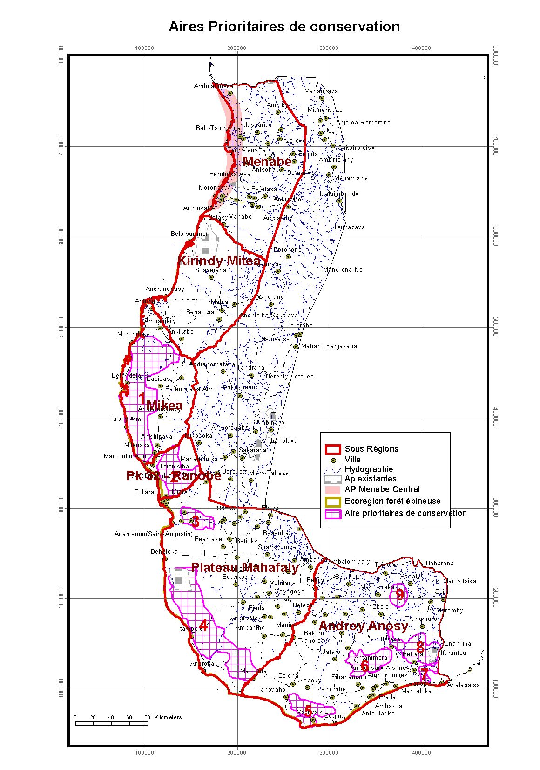
Appendix 1: Conservation Priority Areas. The map shows the southwest spiny forest ecoreigon and is divided into its many sub-regions (red lines). The purple grid areas represent conservation priority areas within the ecoregion. Parts of zones 1, 2 and 3 fall within the limits of Atsimo-Andrefana, where the efforts of SEESO are concentrated. Toliara is indicated on the south-central west coast by a bulls-eye (Rasolonandrasana 2010 slide 5).
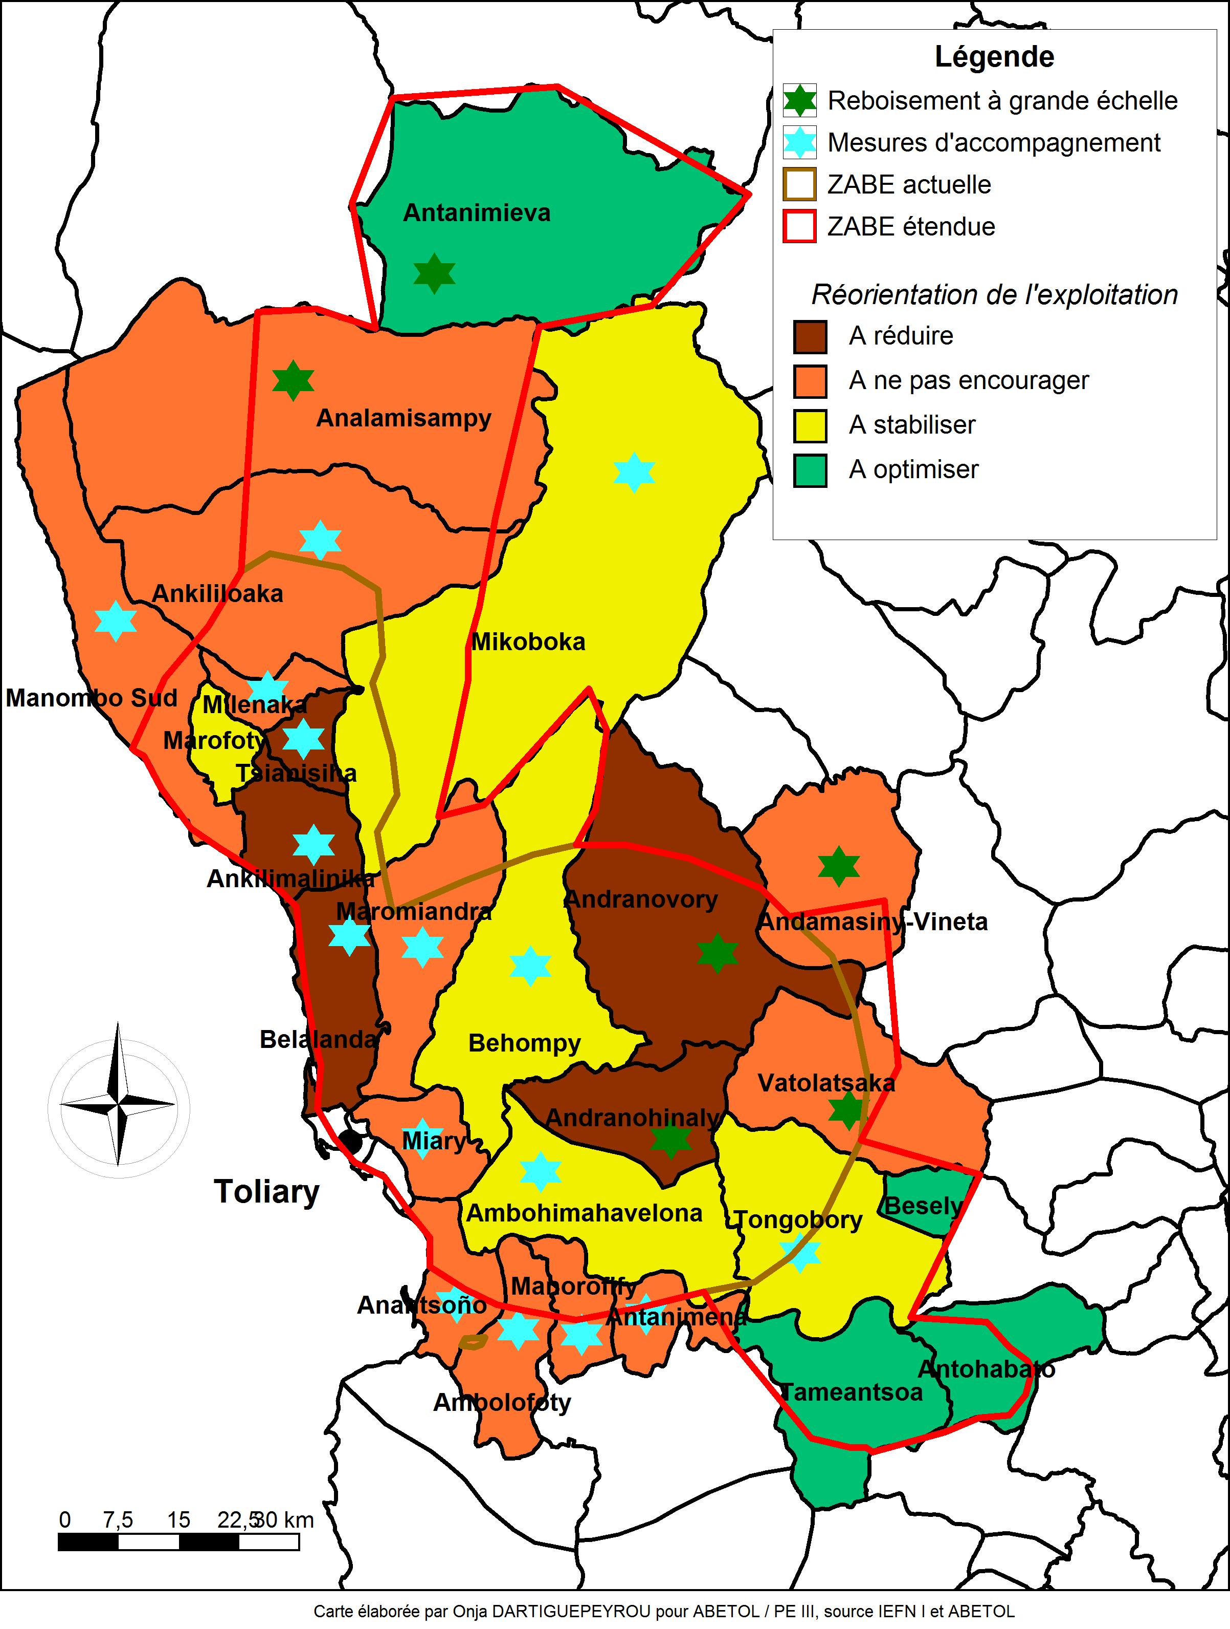
Appendix 2: Proposed reorientation strategy for fuelwood exploitation and related activities in the Atsimo-Andrefana region. Areas in brown are zones where exploitation should be reduced, in orange exploitation is to be discouraged, in yellow exploitation is to be stabilized and in green exploitaion is to be optimized. Areas marked with green stars are large scale reforestation effort zones. Areas marked with blue stars are zones where complementary strategies are employed. The region outlined in red represents the planned intervention zone, whereas the region outlined in brown represents the actual intervention zone. Note the 3 principal commnities in which volunteers worked are marked in brown and extend north from Toliara, they are Belalanda, Ankilimalinika (where volunteers were based) and Tsianisiha.

